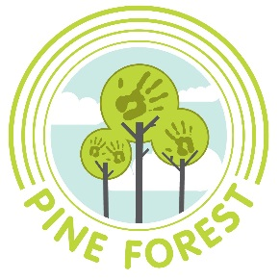
Permission and Instructions for Administering:
Sunscreen, Bug Repellent, Lotions, Chapstick, and Diaper Cream
(Parents must provide product(s) for their child.)

Child’s Full Name:___________________________________________

Today’s Date:___________________

Name of Product:____________________________________________

Please label each product with your child’s full name on it. Thank you!
When and how to administer: __________________________________________________________
Date to Begin:_______________________________________________

Possible side effects, storage instructions or other pertinent information:

________________________________________________________
Important: Aerosol sunscreens are not permitted by VT Licensing Standards.
*********************************************************************

I, ______________________ hereby give permission for Pine Forest Children’s Center to administer the above product, which I have provided in its original labeled container to my child, _____________________, as indicated above.

Parent or Guardian’s Signature: ________________Date: ____________

Please return to your child’s teacher. Thank you!

